SANDHILLS FBLA MEMBERS ATTEND NATIONAL CONFERENCE

On November 14, six Sandhills FBLA members (Brea Branic, Lindsay Cody, Jacob Furrow, Miriam Ganoung, Madison Glidden, Courtney Swisher); two Sandhills FBLA Middle-Level members (Zoe Barela and Charlsie Teahon), and their adviser, Celeste Rogers traveled to the National Fall Leadership Conference held in Denver, Colorado. The Conference was held at the Downtown Denver Sheraton.
Members from across the country attended this regional conference, the third held this fall. The first two being in Washington, DC and Birmingham, Alabama.
On November 15, the Nebraska delegation had tours of Hammond Candy Company, Mile High Stadium, and Denver Branch of the Federal Reserve Bank of Kansas City. Everyone enjoyed themselves at each stop. After the tours, there was a stop at the mall. Then everyone prepared for the Nebraska Meeting and the Opening General Session. Sandhills FBLA was recognized as a Super Sweeps recipient during the Nebraska meeting. The speaker for the opening session was John Guydon. Mr. Guydon spoke about his life story and how to grow while maximizing efficiency in our lives.
On November 16, the Sandhills troupe attended workshops and the closing general session. Anne Bonney, the speaker for the closing session, spoke about how change can be uncomfortable and how it also can be good. A Blue Jeans for Babies Dance to benefit the March of Dimes was held following the closing session.
Around midnight, Nebraska FBLA got back on the road again for the long trip home.
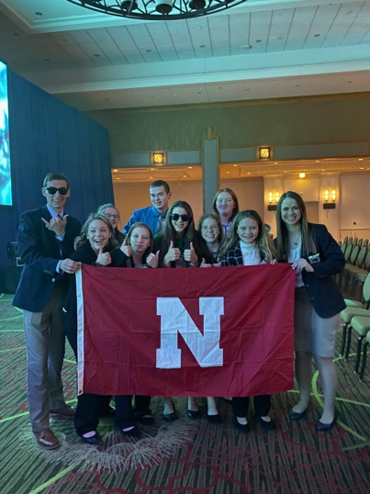
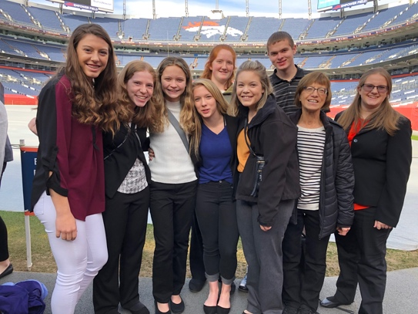
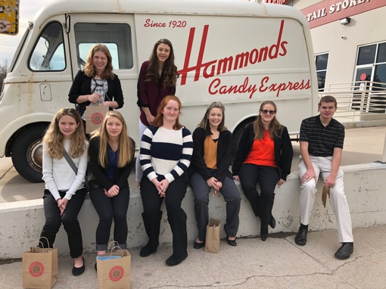
Touring Bronco Stadium Touring Hammonds Candy Co.
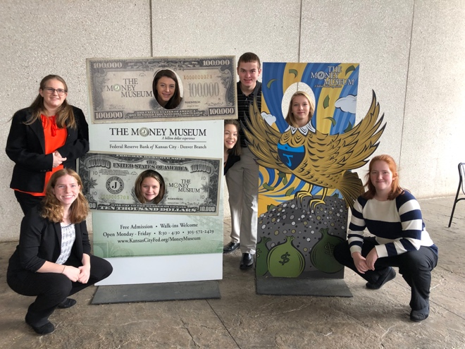
AtConference

At the Fed in Denver

